AWS TASK 4

**Task Description:**

Launch an EC2 instance (Linux and Windows) along with a web server. Then, create an EBS volume of 5 GB, attach it to an EC2 machine (Linux and Windows), and take a snapshot. Finally, create an EBS volume using the taken snapshot.

EBS volume created for 5 GB:

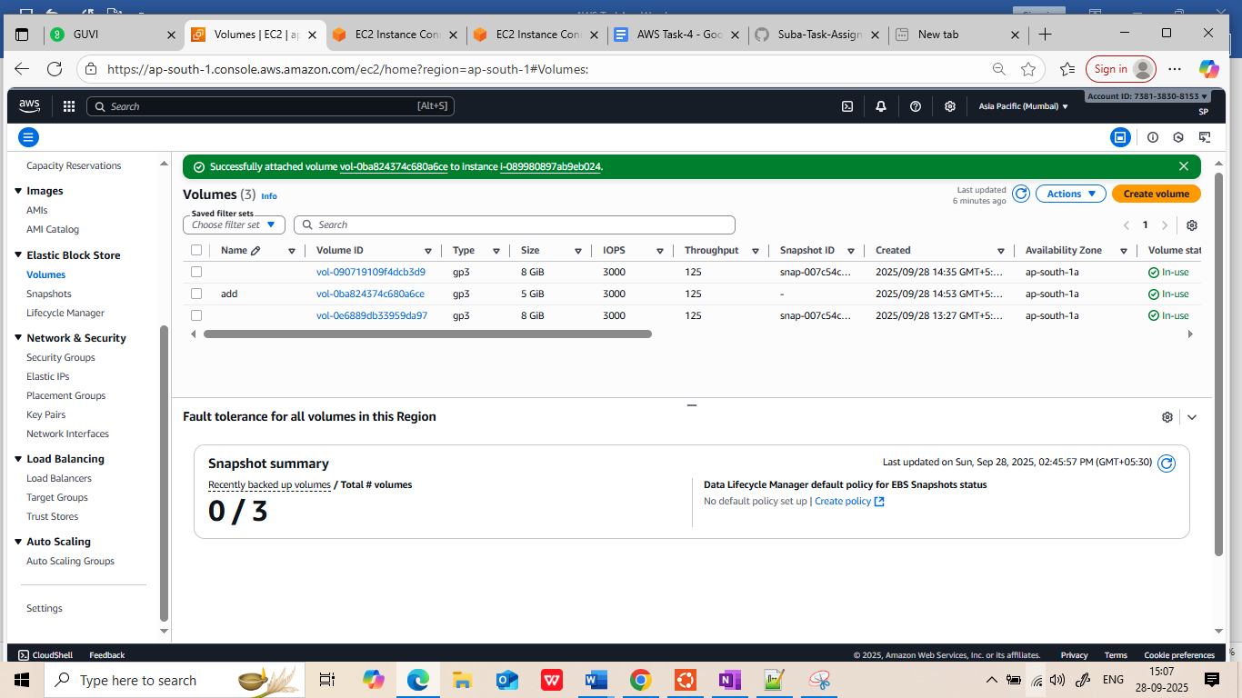

Directory path created, filesystem created and mounted the FS into path.

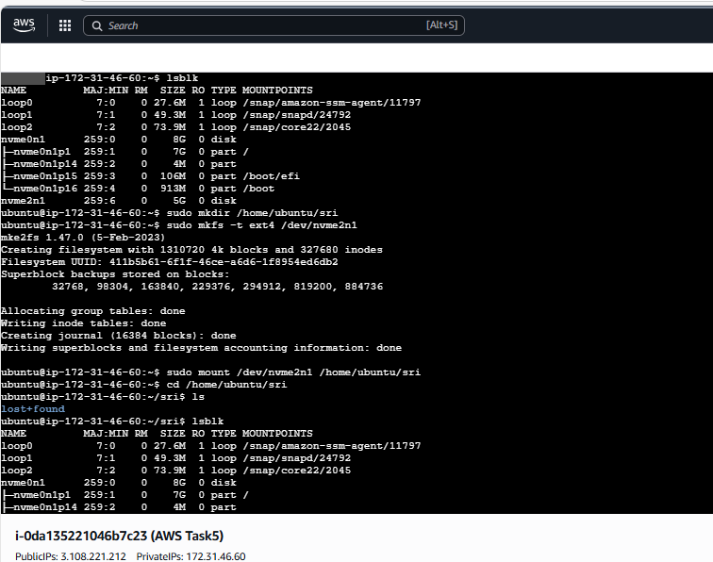

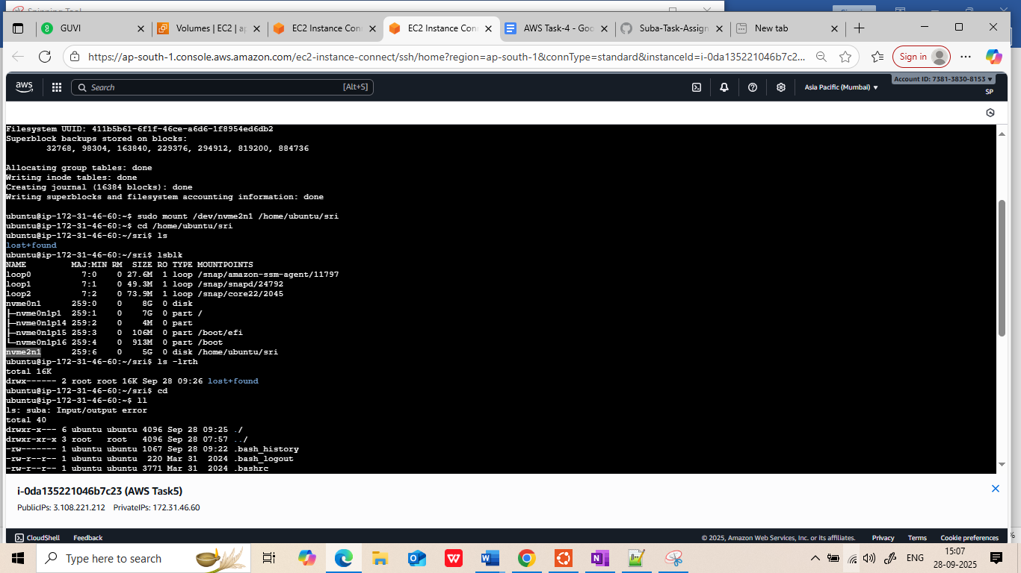

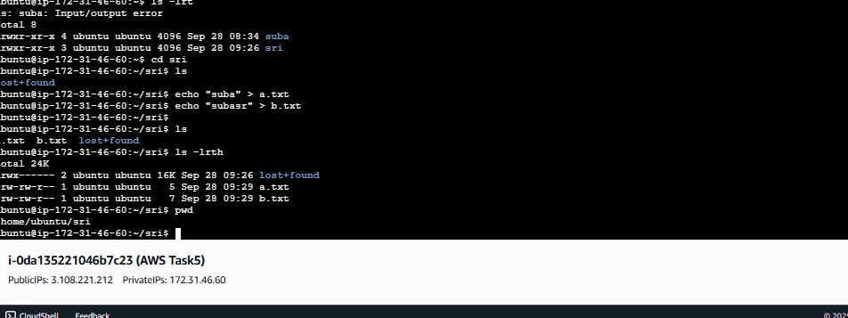  
  
  
Detached and attached into the server 2:  
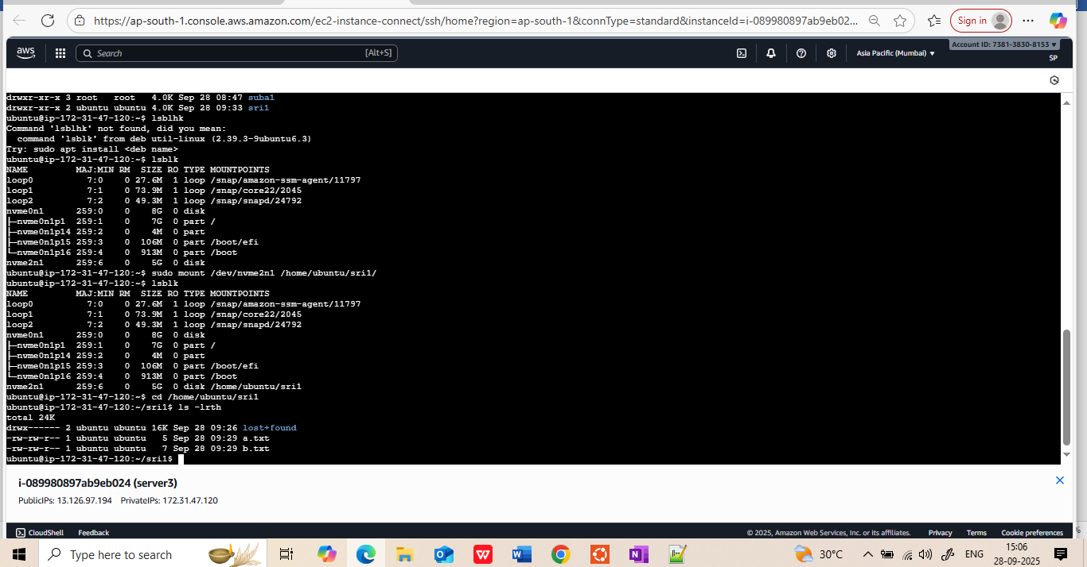  
  
Snapshot created for volume :  
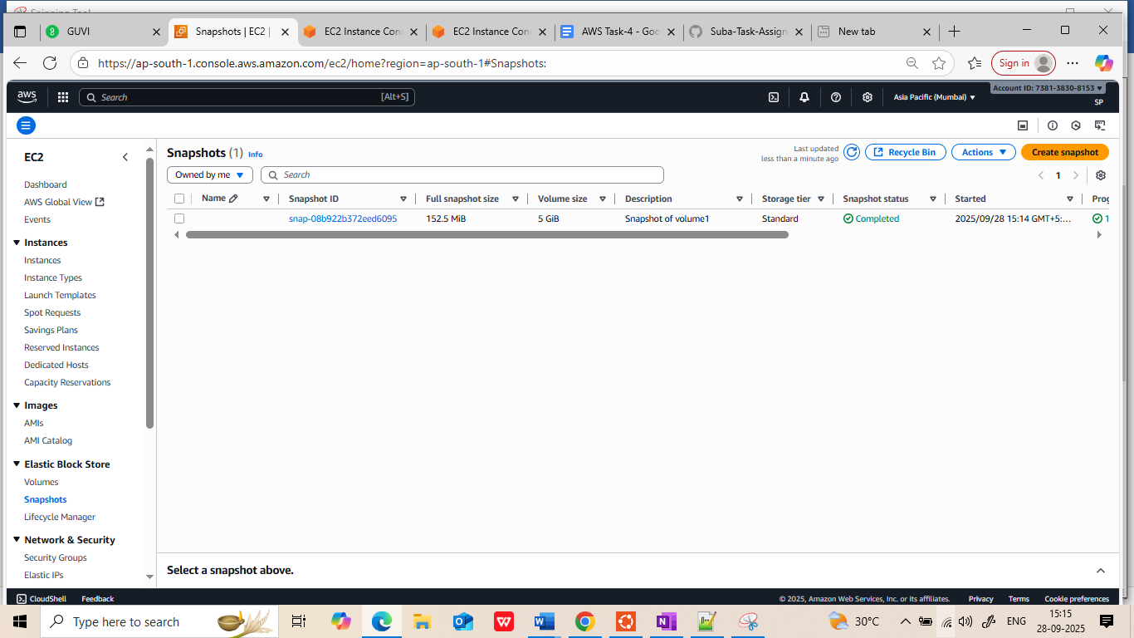  
  
deleting the volume and create a volume based on the snapshot :  
  
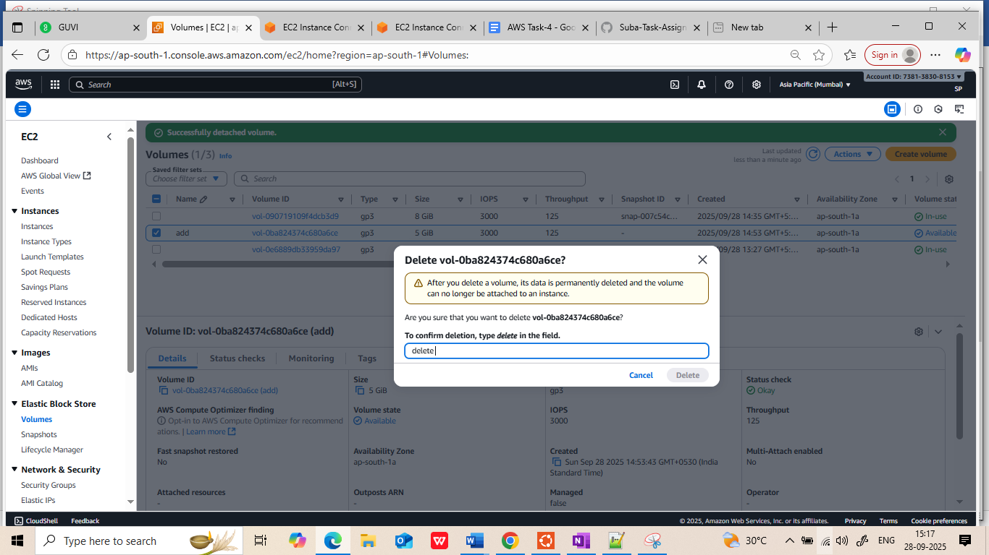

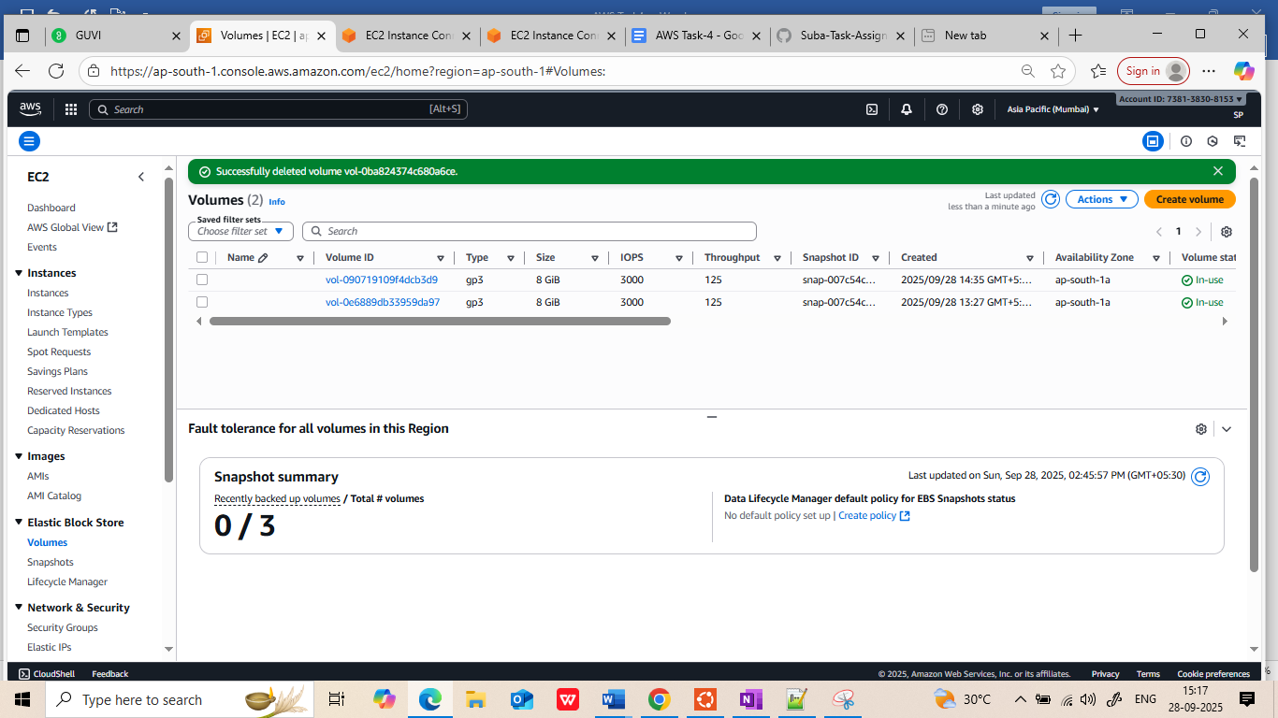

Creating volume from the sanpshot:

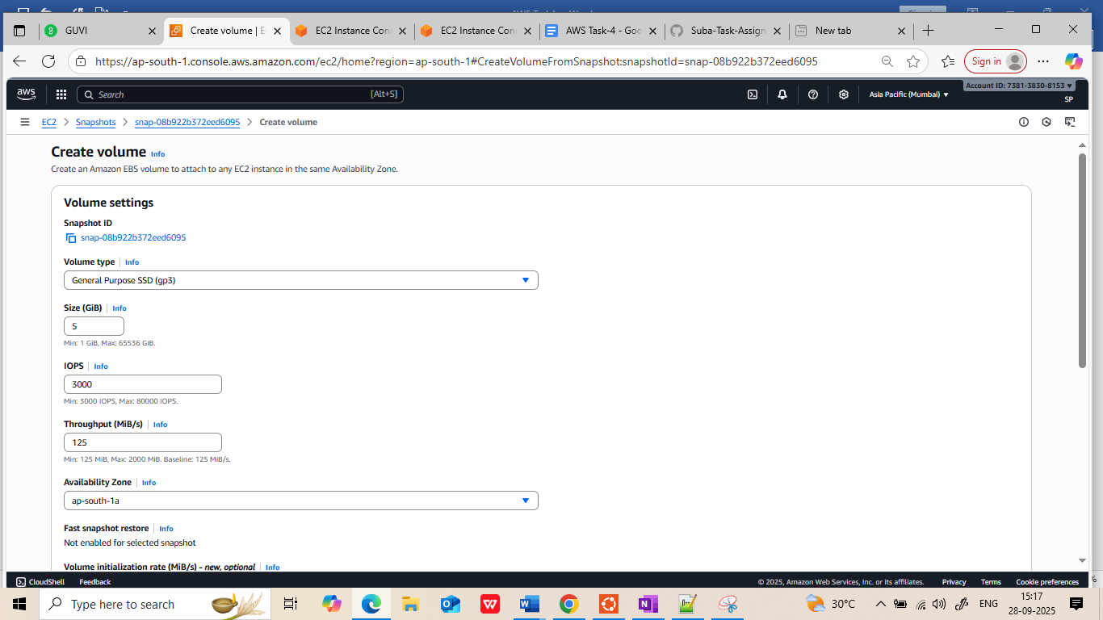

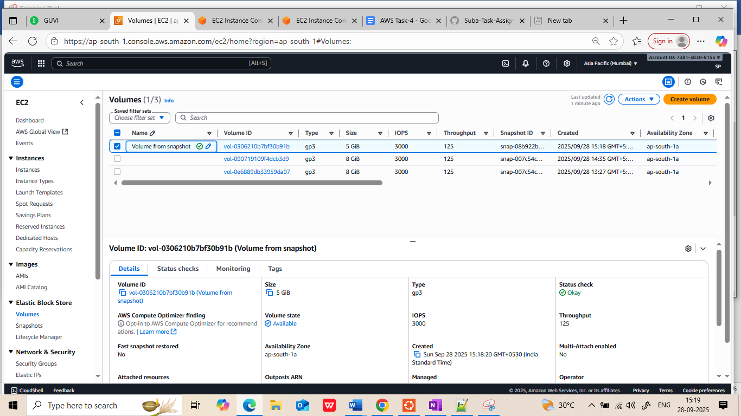

Windows:

diskmgmt.msc

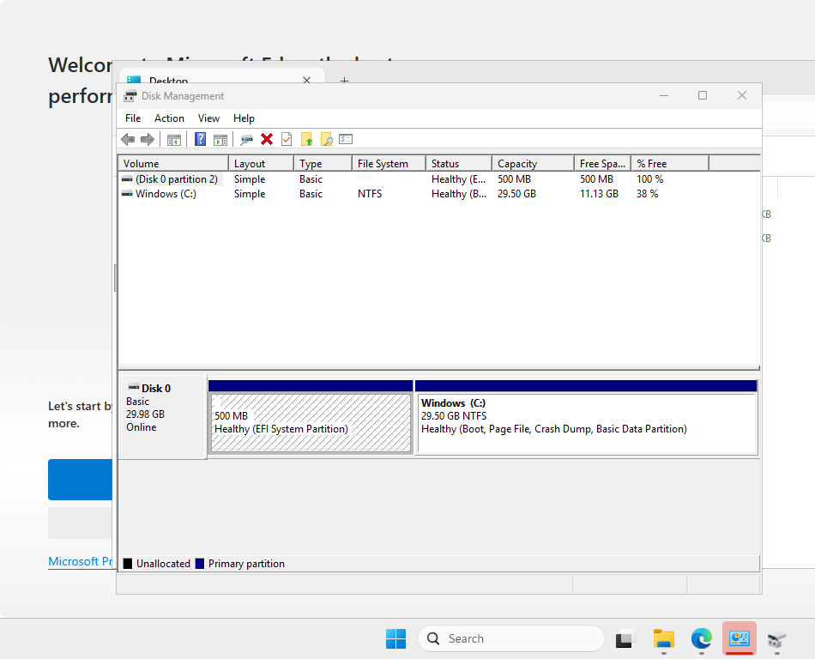

Mounted new volume to windows server

